1.14: a) 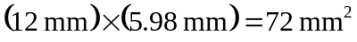 (two significant figures).
b)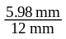 = 0.50 (also two significant figures).
- 36 mm (to the nearest millimeter).
- 6 mm.
- 2.0.

